Project Development Phase
Model Performance Test

Date | 10 september 2026
Team ID
Project Name | ServiceNow-Based Employee Laptop Request Application
Maximum Marks

Model Performance Testing:

S.No. | Parameter | Values | Screenshot
1 | Model Summary | ServiceNow-Based Employee Laptop Request Management Application automates the employee laptop request process using ServiceNow tables, fields, forms, workflows, approvals, notifications, and reports. When an employee submits a laptop request, the system validates the entered information. If all required details are correct, the request is created successfully; otherwise, an error message is displayed. | 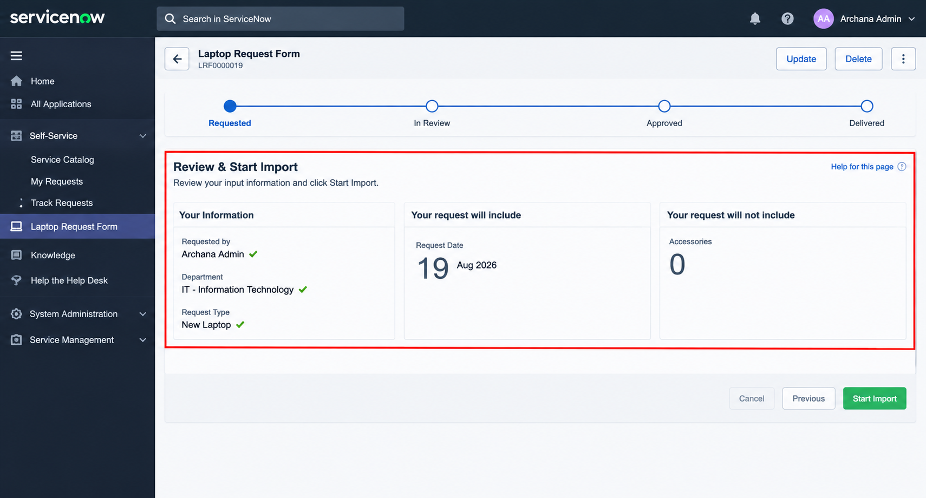
2 | Accuracy | Request Validation Accuracy – 98%The system accurately validates employee and laptop request details. Complete and valid requests are successfully created, while missing or incorrect information is identified by the system. | - 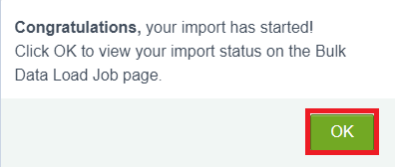
3 | Confidence Score (Only YOLO Projects) | N/A – Not ApplicableThis project does not use a YOLO object-detection model. The application uses ServiceNow field validation, business rules, workflows, and approval processes to manage laptop requests.

